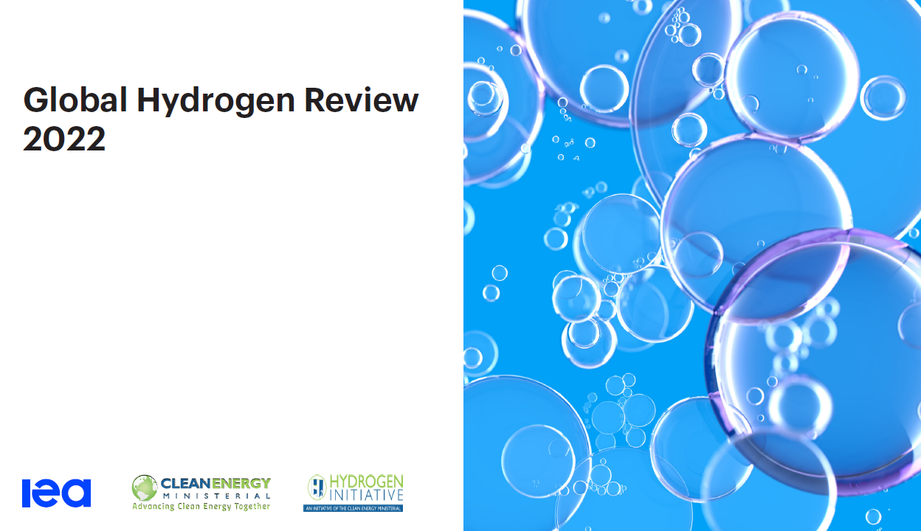

**Global Hydrogen Review 2022**

**Summary**: the Global Hydrogen Review is an annual publication by the International Energy Agency that tracks hydrogen production and demand worldwide, as well as progress in critical areas such as infrastructure development, trade, policy, regulation, investments and innovation. Focusing on hydrogen’s potentially major role in meeting international energy and climate goals, this year’s Review aims to help decision makers fine-tune strategies to attract investment and facilitate deployment of hydrogen technologies while also creating demand for hydrogen and hydrogen-based fuels. It compares real-world developments with the stated ambitions of government and industry.

**Tags:** energy transformation, hydrogen market, hydrogen, hydrogen policy, energy transition, green hydrogen.

[**Global Hydrogen Review 2022**](https://read.oecd.org/10.1787/a15b8442-en?format=pdf)